SAINT PETER CLAVER AND SAINT PIUS V

“ONE IN THE SPIRIT”

1546 N. Fremont Avenue Baltimore, Maryland 21217

Office: 410-669-0512 410-523-1930
Fax: 410-383-8227 Hall: 410-728-1729

Thirty-eighth Sunday in Ordinary Time
October 14, 2018

PASTORAL STAFF

Pastor: Rev. Ray P. Bomberger, S.S.J.
Rev. Lowell D. Case, S.S.J.
Deacon Willard Witherspoon, S.F.O.

STAFF

Ms. Deborah Holly
Mrs. Crystal Morris
Sr. Alice Talone, CBS
Mrs. Evelyn Watkins

MASS SCHEDULE

Daily Masses


Mondays: 12:00 noon
Tuesdays Thursdays Fridays: 8:00 am
Wednesdays: 10:00 am

Weekend Masses

Saturday Vigil: 4:00 pm
Sunday: 8:00 am, 10:45 am

Holy Days

To Be Announced

Confessions

Before the Mass

Religious Education

Elementary & First Communion

Sundays: 9:15 am

High School & Confirmation
1st, 3rd, 5th Fridays: 7:00 pm

Bible Study

Mondays: 10:30 am & 7:00 pm

Rite of Christian Initiation

For Adults
Sundays: 12:30 pm

Baptism & Marriage Preparation
By Appointment

Go to www.josephites.org,
click Parishes and School tab,
select Maryland, then click the
parish name.

Readings for the Week of October 14, 2018

Sunday: Wisdom 7:7-11 / Hebrews 4:12-13 / Mark 10:17-30
Monday: Galatians 4:22-24, 26-27, 31—5:1 / Luke 11:29-32
Tuesday: Galatians 5:1-6 / Luke 11:37-41
Wednesday: Galatians 5:18-25 / Luke 11:42-46
Thursday: 2 Timothy 4:10-17b / Luke 10:1-9
Friday: Ephesians 1:11-14 / Luke 12:1-7
Saturday: Ephesians 1:15-23 / Luke 12:8-12
Sunday Isaiah 53:10-11 / Hebrews 14-16 / Mark 10:35-45
Word From The Pastor

October is the month of the Rosary. In his book, “Mary, Mother of All”, Pope Francis teaches the meaning of the words of the Hail Mary.
The angel Gabriel calls Mary “full of grace”. In her, Pope Francis explains, “there is no room for sin, because God has chosen her from all eternity to be the mother of Jesus, and has preserved her from original sin. . . . the Word became flesh in her womb. We, too, are asked to listen to God, who speaks to us, and to accept His will. The Lord always speaks to us.”
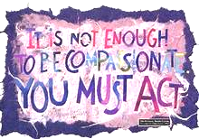
“The Lord is with you.” What happened in a unique way in the Virgin Mary “happens on a spiritual level in us as well when we welcome the Word of God with a good and sincere heart and put it into practice. It happens as if God were to become flesh in us; He comes to live in us, because He makes His home in those who love Him and obey His Word. It’s not easy to understand this, but, yes, it’s easy to feel it in your heart. Do we think that the incarnation of Jesus is only a past event, that it doesn’t affect is personally? Believing in Jesus means offering Him our body, with the same humility and courage as Mary.”
“Blessed are you among women” how did Mary live her faith? “She lived it, “Pope Francis answers, “in the simplicity of the many daily occupations and worries of every mom, such as providing food and clothing and taking care of the home. . . . Precisely this normal existence of the Virgin was the ground on which a singular rapport and profound dialogue between her and God, between her and her Son, developed.”

Mass Intentions
Saturday 4:00 pm: Bernice Lewis
rb: The Family
Sunday 8:00 am: Mamie Bolden
rb: Marjorie Purvey


Deceased Josephites
October 15 – Rev. John J. Conlon, SSJ
October 16 – Rev. Michael J. O’Neil, SSJ
October 17 – Rev. Michael L. Gumbleton, SSJ
Rev. Edward V. Casserly, SSJ
October 18 – Rev. Charles P. Brown, SSJ
Scripture Insights

What are your priorities in life? Today’s readings reflect on this challenging question.
In the Book of Wisdom, the writer prays to God for the spirit of wisdom to be given to him. Wisdom is God’s greatest gift, since it provides true insight into how to lead life with integrity—a gift far more precious than gold, silver, or even health!
Today’s Gospel offers us a concrete example of a man discerning his priorities in life. He comes running to Jesus with enthusiasm, eagerly asking: “What must I do to inherit eternal life? Jesus tries to curb his enthusiasm and deepen his understanding by challenging him to consider exactly what his priorities are. The Lord focuses on those commandments that involve how we lead our lives and treat our neighbor. They all reflect a common thread: “I have never done anything to harm anyone!” But, Jesus implies something more is needed: “What have you done to help another person.”
Looking into this man’s heart, Jesus says in effect: “you consider that leading a good life entails not harming others. Instead, spend your resources in doing good for others.” Unfortunately, the eager young man could not accept Jesus’ challenge, and he walked away.
This rich man was presented with the challenge of accepting the real priorities in his life: using his gifts and talents to help others. We discover true happiness in serving others. This challenge is presented to us well: to discover our true priorities and scale of values and to implement them in our lives.
Liturgical Training Publications


Feasts and Memorials
October 15 – Saint Teresa of Avila
October 16 – Saint Margaret Mary Alacoque
Saint Hedwig
October 17 – Saint Ignatius of Antioch
October 18 – Saint Luke
October 19 – Saint Isaac Jogues
October 20 – Saint Paul of the Cross

As each one has received a gift, use it to serve one another as
good stewards of God’s varied grace.”
1 Peter 4:10

Attendance ....................................... 180

Collection .................................................. $ 5,022.00
Monthly Collection ……………………………… $ 1,317.00
Monthly Collection ……………………………… $
4,867.00
Monthly Collection ......................... $ 1, 015.00

CELEBRATING 125 YEARS & MORE
The St. Joseph Society of the Sacred Heart, our Josephite Priests and Brothers, invite you to celebrate their 125 years and more of evangelization in the African American community. Please join the Josephite Fathers and Brothers for their Mass of Thanksgiving at the Basilica of the National Shrine of the Assumption of the Blessed Virgin Mary on Saturday, November 17th at 5:30 P.M. The celebration continues with a reception and dinner at the Baltimore Convention Center from 7:30 P.M to 11:30 P.M. Banquet tickets are available online at www.josephites.org. Please contact Fr. Ray for more information.
They serve us well! Let us Celebrate!

PARISH CALENDAR MEETING

On Sunday, November 11th after the 10:45 am Mass, the 2019 Parish Calendar meeting will be held. The Pastoral Council, all ministries and organizations must return their completed calendar form with their dates for inclusion by November 3 / 4. You may drop off completed forms at the Rectory. Those with weekend and/or conflicting dates must attend the meeting.

THE WORD OF THE LORD
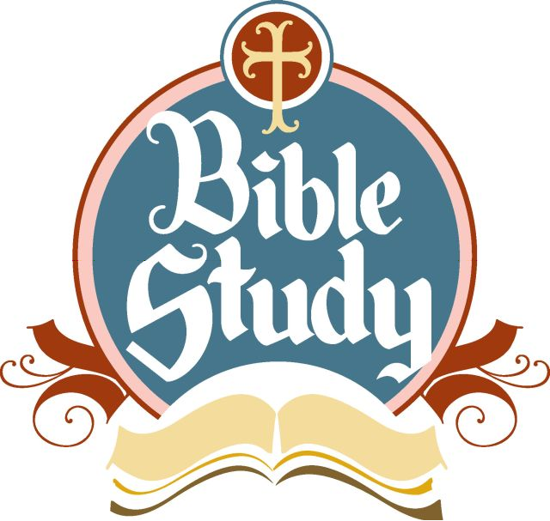
Explore the Scriptures with our Monday Bible Study Groups. Morning Bible Study begins at 10:45 in the Rectory with Fr. Ray or Fr. Father Case, with the noon Mass. The Evening Bible Study Group meets at 7:00 pm in the rectory with Deacon Will.

EXPLORING THE FAITH
If you have questions about the Catholic Church, or would like to return or become a member of the faith. RCIA is for you. Contact Fr. Ray, Fr. Case, Deacon Will or call Deacon Will at410-599-8327.

IT’S A “Y” FOR CIRCLE WINNERS!
Congratulations to our October Circle Winners:
President 049 $500 Dorothea Small
1st Vice President 091 $ 50 Unsold
2nd Vice President 037 $ 50 Christine Barnes
Secretary 001 $ 50 Fr. Ed Chiffriller
Treasurer 081 $ 50 Evelyn Watkins
Join us for Bingo and the next Circle Drawing on Monday, November 12th in Fr. Henry Harper Hall. Pick up your new Circle Books from Catherine Case.

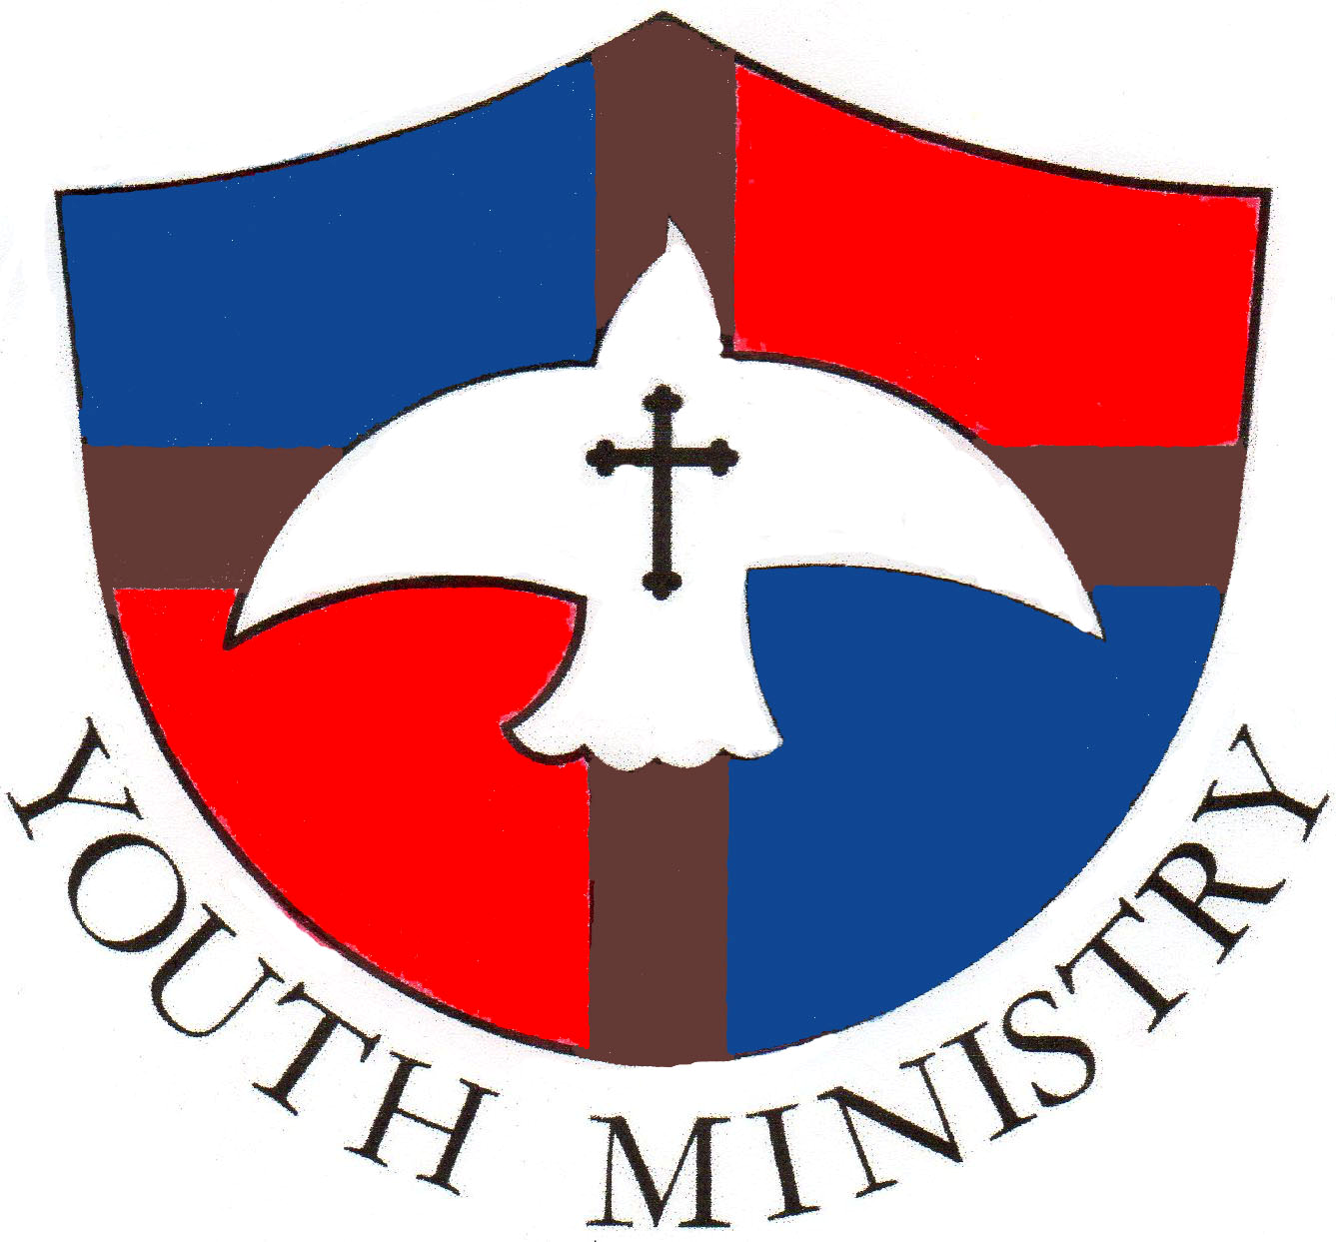
MEETING THIS WEEK
Our Saints In Progress meet this Friday at 7:00 pm. Parents, see that the teens in your family attend.

EMERGENCY FOOD BASKET
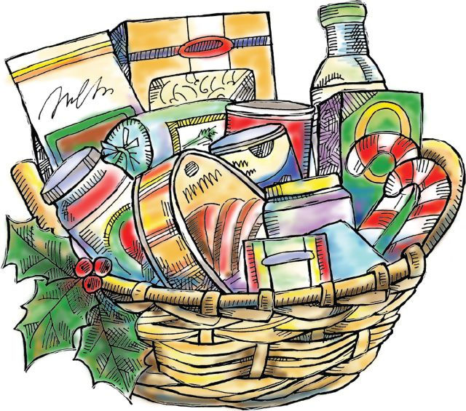
Don’t forget the needy. Drop canned goods, pasta and pasta sauce, peanut butter, mac’n cheese, jelly, oatmeal, cereal and powdered milk into our food basket at Mass. Thank you for your generosity.

SAVE THE DATE : PLAN TO JOIN US
St. Peter Claver and St. Pius V will celebrate our union and historic roots with Mass at 10:30 am and a reception in Fr. Henry Harper Hall on November 4th.
For the meal count, please print your name and each name of those coming with you on the RSVP sheets located at the back of the church. Thanks.

During the Mass our ancestors will be honored with the blessing of our “Ancestry Love Ones to Remember Book.” We invite you to add the names of family, friends and spiritual mentors who are deceased between the years “2014 and 2018” on the sheets at the back of the church.

During the reception, we’re going to see how much you remember about St. Peter Claver and St. Pius V. There is time to study. Take home a bulletin with our “Did You Know” parish fact sheet today.

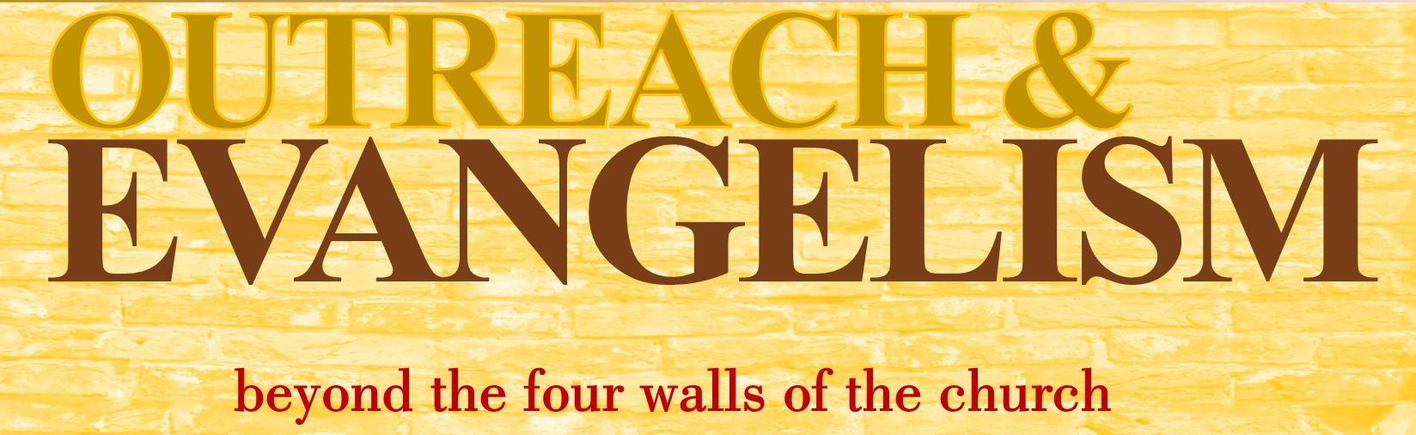


Visit the Josephites website for their recent news, and visit our new parish webpage, saluting St. Pius V Parish photos from “years gone by” for our historic celebration. Logon to www.josephites.org, then continue to our pages by clicking “Parishes and School”, select “Maryland” then click our parish name. We’re in color on the Net!

SERVING THE NEEDY
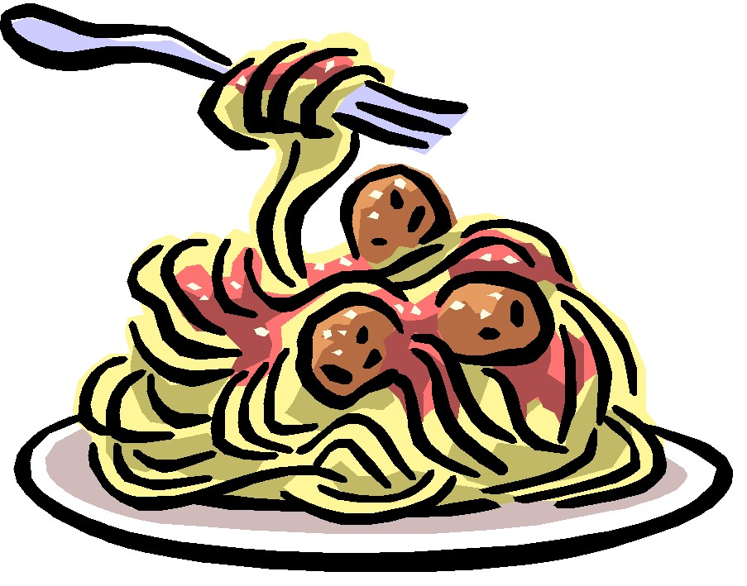
Support our St. Vincent de Paul Society Food Pantry by offering these items at Mass: Canned Tuna, Mac & Cheese, Pasta and Sauce, Canned Pork & Beans, Vegetables and Beef Stew, Peanut Butter, Jelly, Powdered Milk, Oatmeal, Cereal, Jello.
Cook for Our Daily Bread Casserole Program by picking up a pan and recipe on the Second Sunday of the month and return your casserole on the Third Sunday for Monday delivery. The next date to pick up casserole pans is the weekend of October 13 / 14 with frozen casserole returns the following weekend of October 20 / 21 .

COMMUNITY RESOURCES

FRANCISCAN CENTER “SUPPER CLUB
The Franciscan Center, located at Maryland Avenue and 23rd Street, in addition to their daily Lunch Program now has a “Supper Club” serving a free hot meal on Wednesdays from 5:30 pm to 7:00 pm to any one who is hungry.

FOOD SERVICE TRAINING
The St. Vincent de Paul offers the free “Next Course” Food Service Program” that provides applicants with food service skills, and the opportunity to obtain the ServSafe Food Handlers Certificate and ServSafe Manager’s Certification. This program is a part of the St. Vincent’s KidzTable, located at 1901 62nd St., Suite 3906, Baltimore 21237. For more information contact the Next Food Service Program at 410-982-0855.

ST. EDWARD’S WORKFORCE DEVELOPMENT CENTER
Located at 2848 W. Lafayette Avenue, 3rd floor, the Center provides job preparation and supportive services that include basic education and GED preparation, Auto technician training and certification, computer literacy, child support enforcement and mediation, substance abuse referrals and more. Call 443-885-0990 or fax 443-885-0991.

EMPLOYMENT TRAINING AND JOB PLACEMENT
The Center for Urban Families (2201 N. Monroe St.) provides tax preparation, job training and placement assistance upon completing the four week training program. Services include GED classes, Fatherhood/Parenting classes and occupational skills. No experience is needed nor a High school diploma is required. Call 410-367-5691 or online at www.CFUF.org
CAREER OPPORTUNITIES
The American Health Career Institute, located at 2520 Pennsylvania Avenue, 2nd floor, offers training in a variety of health careers, among them: EKG Technician, Nurse Support Technician, Pharmacy Technician, First Aid and CPR and GED classes. Morning and evening classes are available with flexible payment plans. Logon to www.americanhealthcareer.com. Contact the Institute: Phone: 443-438-4546, Fax: 443-869-3712.

FREE GED CLASSES
Bon Secours Community Works sponsors free classes, for those wishing to complete their high school education, on Mondays through Thursdays from 9:00 am to 2:30 pm at Bon Secours Family Support Center, (26 N. Fulton Ave.) Free child care for children up to 4 years is available. Contact Ms. Brenda K. Jones at 410-362-3695.

PLEASE SUBMIT ALL ANNOUNCEMENTS AND BULLETIN ITEMS BY WEDNESDAY MORNING!

